Mr. Sabado, Pre-Algebra Monday, October 28, 2013

Homework

Due Today:
-Extra Credit

Due 10/29:
-Page 106: 11-31 odd
Page 113: 1-25 odd

Chapter 2 Test on Thursday!!!

Agenda

- Pick-up Calendars
- Warm-Up

- Turn in Extra Credit

- Grade Quiz

- Lesson: Solving One-Step Inequalities

- Class Work: Exit Ticket

- Return Graded Work

Warm-Up

Solve
- 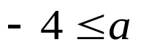
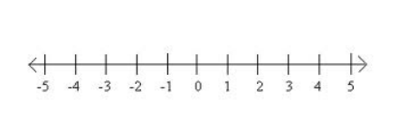

2) 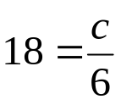


whs.saba.do

“It is never too late to be what you might have been.”
- G. Eliot

